**OUTREACH SCHOOLS EXAMINATION BOARD**

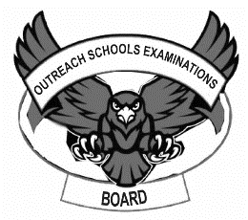 **BEGINNING OF TERM III EXAMINATION 2024**

**PRIMARY ONE**

**RELIGIOUS EDUCATION**

**My name is ___________________________________________**

**I am in ________________________________________________**

**My school is __________________________________________**

1. Who created the world**?**

_______________________________________________________________

1. **Draw these sources of light God created.**

|  |  |  |
| --- | --- | --- |
|  |  |  |
| sun | moon | stars |

1. Jesus was born on __________________________________ day

(Easter, Christmas)

1. How many times do Muslims pray a day**?**

____________________________________ times . (seven, five)

1. Name the holy book for Christians.

_______________________________________________________________

1. **Match people to their roles**

mother paying school fees

father fetch water

children cooks foods

1. **Tick any three people who need help**

sick people boys lame people mother baby teacher

1. **Draw the body gifts from God**

|  |  |  |
| --- | --- | --- |
|  |  |  |
| legs | head | ears |

1. ___________________________________ was the mother of Jesus.(Sarah, Mary)
2. Who was born on Christmas day? _______________________________________________________________
3. The _______________________________ leads prayers in the mosque. (imam, pastor)
4. Christians go to _________________________on Sunday.(mosque, church, shrine)
5. ______________________________ go for prayers on Friday. (Muslims, Christians)
6. Who leads prayers in church? _______________________________________________________________
7. Write down any two examples of birds God/ Allah created.
8. __________________________________________________________
9. __________________________________________________________
10. **Circle any three Muslim names.**

Jane Ali Tom Hamzah Sarah Hadijah

1. **Tick any two ways of caring for plants.**

By watering them

By destroying them

By weeding them

1. **Match parts of the body to their uses**

walking

seeing



smelling

1. 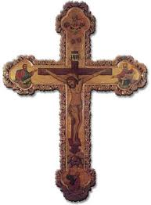 **Name these Christian symbol**

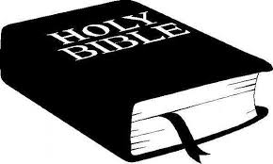

i)______________________________ ii)________________________________

1. **Underline any two things used in baptism**

water paraffin candle glue anointing oil

1. **Draw these things we find in the environment that God created**

|  |  |  |
| --- | --- | --- |
|  |  |  |
| birds | animals | plants |

1. Write down any two wild animals.
2. _________________________________________________________
3. ________________________________________________________
4. **Match these names to their meanings**

Emmanuel saviour

Deborah God is with us

Jesus bee

1. **Draw baby Jesus**

|  |
| --- |
|  |

1. **Name these places of worship**

|  |  |
| --- | --- |
|  |  |
|  |  |

1. **Write R.E in full**

**______________________________________________________________**

***“GOOD LUCK”***